**Group Project Journal for Sprint3**

Name: Peng Ye/ Chen Shen/ Anna

Team: No. 18.

The Master of Sprint3: Chen Shen

Date: 12.04.2018 –- 20.04.2018

1. **Project Management**

Our group’s sprint3 started from 12.04.2018. Actual start date is one week later than originally planned because of the holiday in April. The sprint3 mainly includes data analysis, testing and CSS designing. In sprint3, we have the daily meeting at 9 pm every day and the extra review meeting that helped us review the whole project is held on 19.04.2018.

* 1. **Design, Planning Notes and Materials**

1.1.1 The plan of data analytic features:

TASK1a: Automatically getting data from Mysql database (once / week)

TASK1b: Train data and Train the Machine Learning Algorithm with one mode

TASK1c: Make the prediction on the bike usage condition, the input data could be weather (Rain/None Rain, temperature, humidity, Time duration, e tc.)

TASK1d: Illustrate the prediction data onto webpage

1.1.2 The plan of testing features:

TASK2a: Test the python code by the unit test

TASK2b: Test the display of web application

1.1.3 The plan of CSS designing:

TASK3a: Use simple CSS layout to landscape our webpage

* 1. **Scrum project management (Trello board, slack logs, google docs, Etc)**

Our group mainly use slack and face-to-face communication to manage our project. First, we will do coding in our local machines for each small task and then update it to the Github. Finally, we will download the code from Github to EC2 and make it run in the EC2. After finishing one small task we will do this job and see whether the task has been finished. And we will start next task when we use slack to tell all that we have finished the last task.

* 1. **Meeting notes (log of daily standup, notes from sprint reviews, retrospectives)**

1.3.1 Sprint3 meeting notes:

Date: 12 April 2018

Place: O'Briens Science Centre at 9:30

Present: Dr.A.Lawlor, P. Wicke Chen Shen, Peng Ye, Anna Ryzova

Q1: Update all the features and backlogs and in the meeting we need to talk about what the rest features are.( Like CSS and Testing or any others)

Note: We should add the CSS to our web pages. And Peng has already upgrade the testing feature and data analysis feature into small tasks.

Action: Chen and Peng

Q2: Do we need to add a reviewing meeting in the end of the project?

Note: 4.19 From 9:30

Review all the work. And invite Phil to join our meeting.

Q3: What features or tasks we need to do in the sprint3? (Allocation of Tasks)

Notes: In the next week, we should work together to finish the data analysis part and the CSS part which includes the code integration. In order to work together, we try to arrange time to sit around the table every day and do the coding job in the same version

Action: Chen, Peng and Anna

Q4: Finally, what we need to submit to the teacher? (Both for group and individuals)

Postpone to the next week’s meeting.

Action: None

1.3.2 The reviewing meeting notes

Date: 19 April 2018

Place: O'Briens Science Centre at 9:30

Present: Dr.A.Lawlor, P. Wicke Chen Shen, Peng Ye, Anna Ryzova

Q1: The review of the whole project.

Note: We talked about the problems in the processing of this project. And we reviewed the our work in sprint3.

Q2: How to write and organize the documents?

Note: Follow the instructions in comp30670-2018-group.pdf and the Data Storage.pdf.

1.3.3 Daily standup:

|  |  |
| --- | --- |
| Date | Peng/Chen/Anna |
| 4.12 | Peng  Today: 1. Have Sprint 2 review meeting and Sprint3 meeting 2. Update backlog combing with Sprint1 part and Sprint3 part 3. Wrote Scrum meeting notes Tomorrow, Work on 4 tasks of Data Analytics Part  Chen:  Today, we have the sprint 2 review meeting and sprint 3 meeting. And i am writing the Sprint3 meeting notes. But i am not very sure about whether should we continue our plans? Tomorrow, we will work together on data analysis from 10am in science building  Anna:  I am working on chart 4 today. Tomorrow we will discuss how to work together on the Data Analytics part tasks. |
| 4.13 | Peng  I will keep on working Data analytic tonight and tomorrow  Chen:  Today, i helped Peng with the display of the prediction page. And i finish the sprint3 meeting note and update the Backlog by adding the Intergration features. Tomorrow, we will continue to work on data analysis and try to finish this part. And Peng and me will meet in the science building at 10 am tomorrow.  Anna:  Today we had an extra meeting on our final project stage. We allocated the tasks for the Data Analytics feature. I start on Task 26 from our backlog today. |
| 4.14 | Peng:  Today,  Chen and I worked together on Data Analyzing of Bike Station part. We finished task 24 in backlog, and 80% of task 25 as well. In addition, we finished integration of web page and I have update bike5.html onto github:  http://mytest:5000/bike5/  I will try to finish task 25 and task 26 in backlog, maybe include some testing works as well  Chen:  Today,  1. I worked with Peng on the data analysis. And i trained a model of station1 and predicted the usage of the bikes by the 5 weather features.  2. We also have integrated the earlier codes into one version web application.  Tomorrow,  1. i will continue to integrated the codes and separate the js codes to the .js files. And i will also spend some time on CSS or heat map.  Anna:  I was doing my Task 26 today and about to commit the code that will read the JSON code from Dublin_chart_7 and display it.  Tomorrow will continue. |
| 4.15 | Peng:  Today,  1. I finished all tasks on data analytic part. You guys can have a test with this page:  http://ec2-34-217-16-180.us-west-2.compute.amazonaws.com:5000/bikeReview/  2. worked with Chen on CSS, *,js files's integration on EC2 instance  tomorrow, I will work on some testing work and I will start on document's collection from next Monday on  Chen:  Today,  1. i separate the javescript code to the .js files and update the github  2. i almost finished the heatmap code  Tomorrow,  i will work on the CSS features with you guys  Anna:  Today I was testing the files. |
| 4.16 | Peng:  Today, I didn't do any coding works. tomorrow, I think we may have a quick review on what we have done and what we missed over last week.  Chen:  Today,  1. i did nothing for our project.  Tomorrow,  I think we need to talk about how to write the document together and finish the tasks of CSS feature.  Anna:  I will continue with Chart 4 tonight. We will decide tomorrow what tasks have to be completed in our project and allocate them. |
| 4.17 | Peng:  Today, I changed code on data analytics part according to philip’s suggestions:  1) Use python to dump training model onto particular files  2) Adjust the layout of data analytics page  Tomorrow, I will work on document and CSS  Chen:  Today, i have spent two hours on CSS and our webpage's main colour is blue and white  Tomorrow, we will start writing documents and finish all the code tasks.  Anna:  I spent some time today preparing my Learning Journal 3, notes and all documentation I have up to date. I will upload it to Github until Friday |
| 4.18 | Peng:  Today’s work:  1. Worked with Chen on CSS/Layout integration on flask server. Modified and added new codes and completed the final bits on Bike Station webpage. (5 hours in total)  2. Layout testing work is finished. Only a few text issues to be adjusted.  Tomorrow:  1. Have discussion with Philip on document’s writing  2. Unit testing code writing and integrating to master bit  Chen:  Today, i worked with Peng to finish the CSS of our wep app  Tomorrow, i will finish the project journal of sprint3 and start writing the personal journal.  Anna:  Hi guys, I will attend tomorrow practical |

* 1. **Feature selection/product backlog for sprint3**

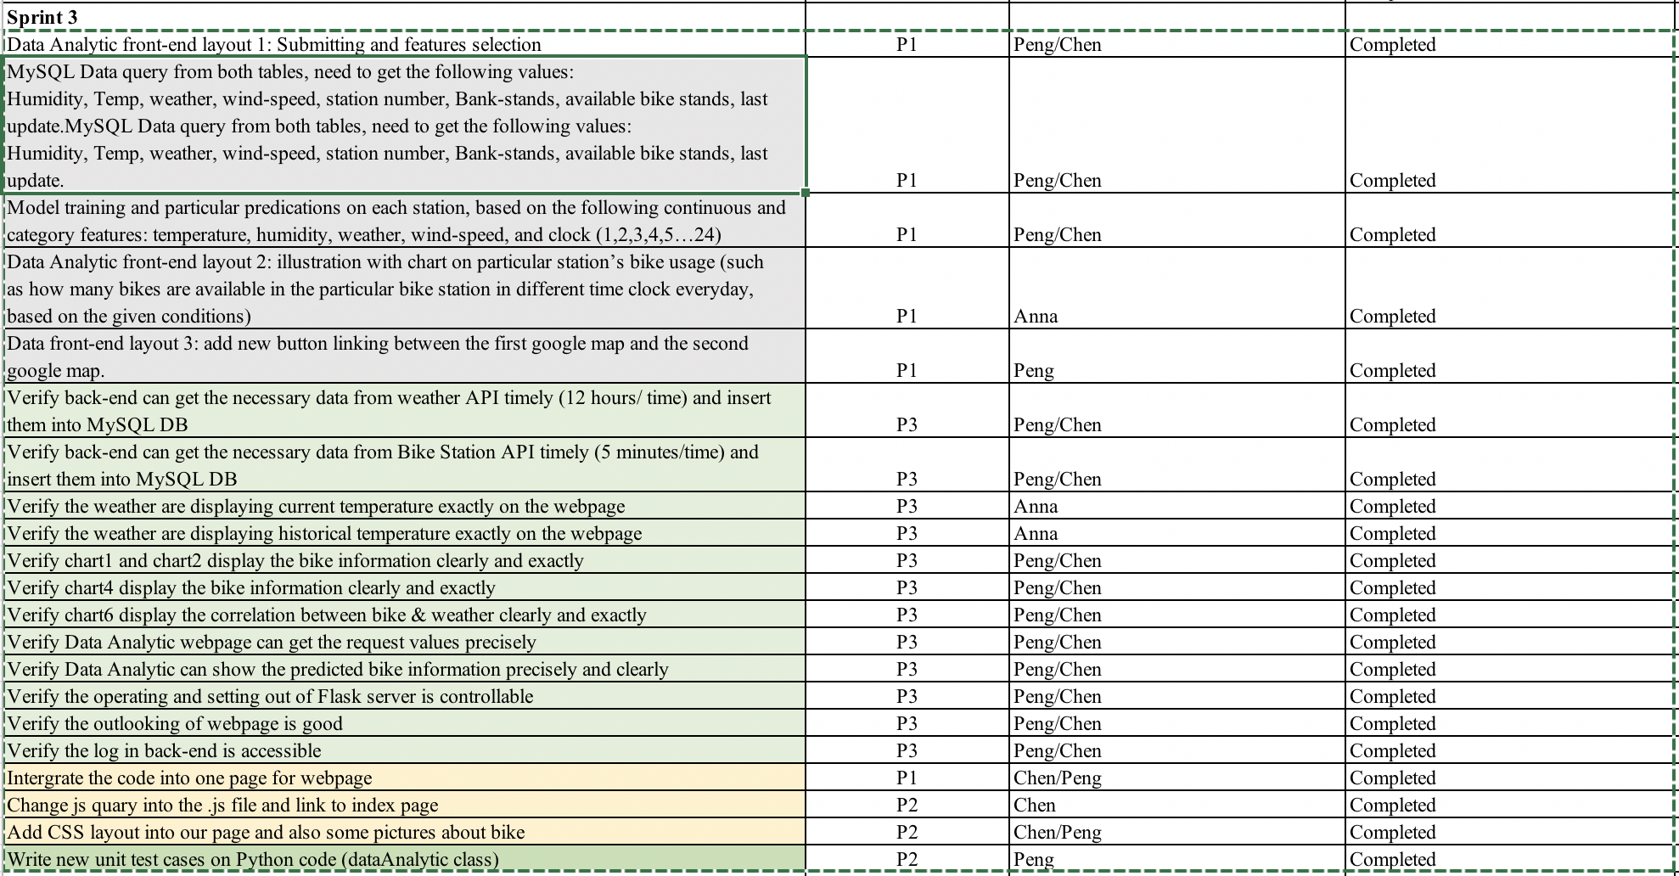

* 1. **Burndown charts, (sprint and/or release) for sprint3**
  2. **Managing deliverables, prototypes**
     1. Data analysis:

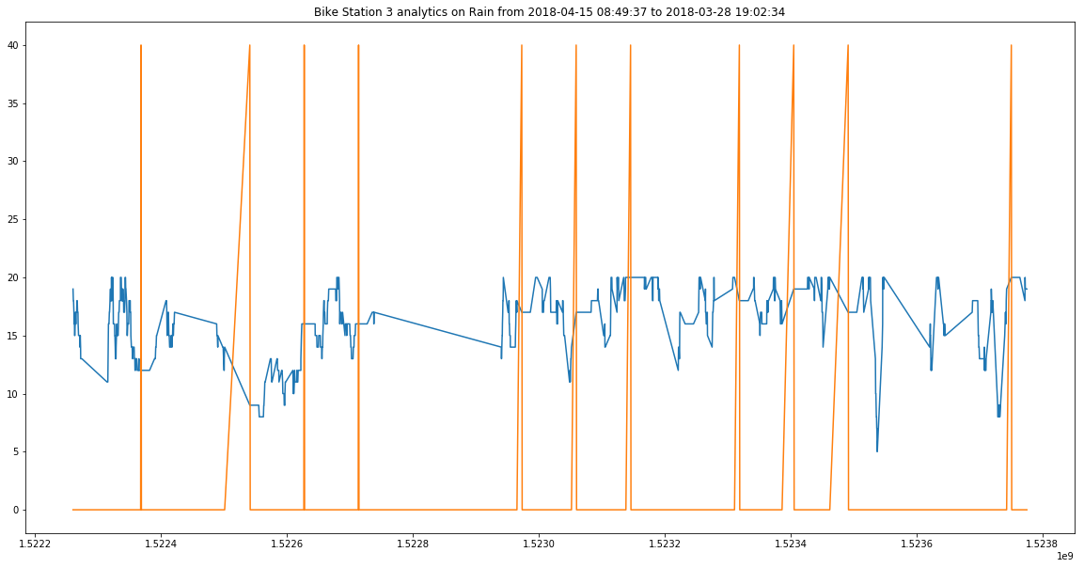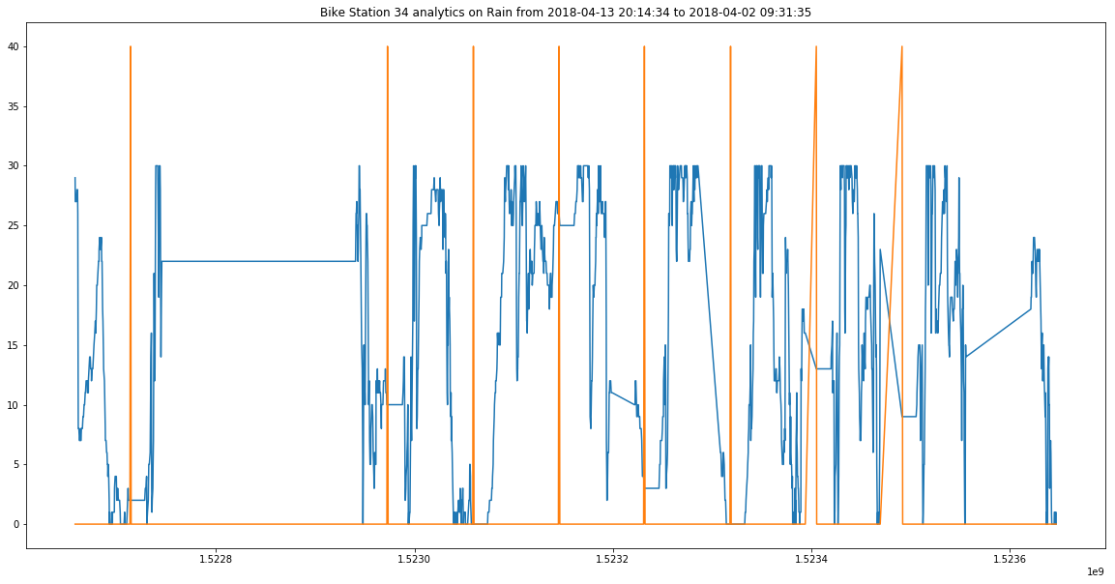

The two pictures draw the tendency of available bikes in station 3 and 34 when the weather is rain. And these pictures show that the model can be trained to predict the available bike tendency.

The deliverables:

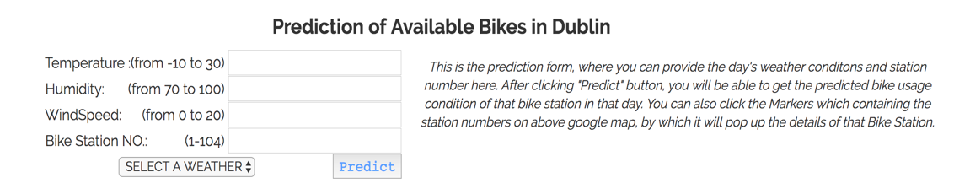

The result of the prediction:

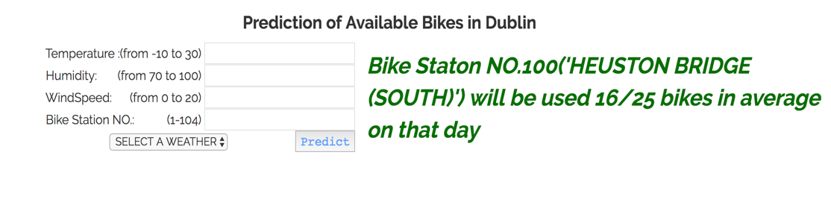

* + 1. Unit testing for python code:

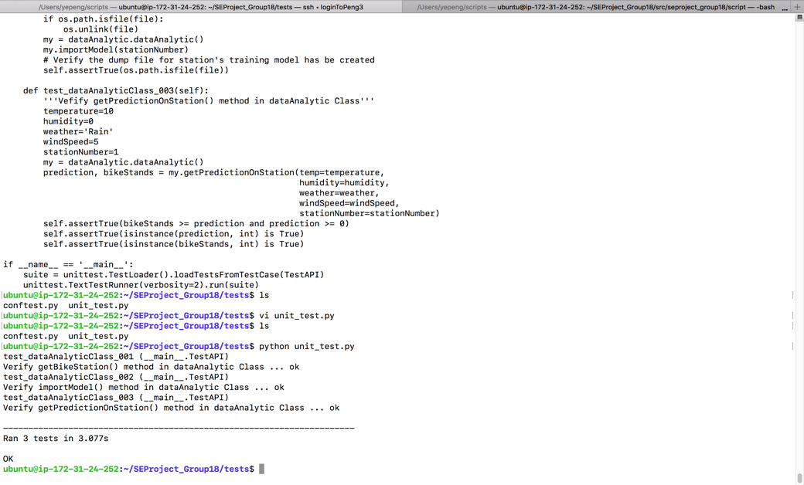

* + 1. Display testing:

This is the instance link and our web application is put in here:

<http://ec2-34-217-16-180.us-west-2.compute.amazonaws.com:5000/>

When click the link, we can see the following picture:



* + 1. The model used in data analysis:

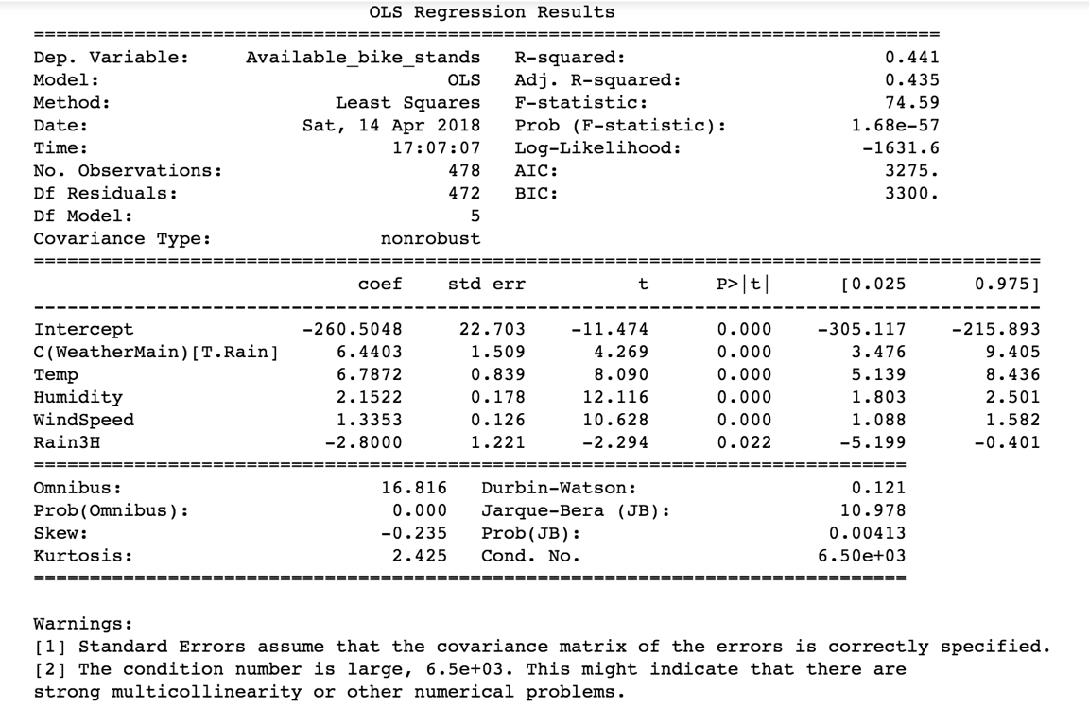

1. **Skills Practiced**

In sprint3, we focus on the data analysis and testing. As a result, the following skills have been practiced:

* 1. Python coding skill
  2. The process of data analysis
  3. Handle the huge data frames
  4. Unit testing
  5. CSS coding
  6. Writing project reports

1. **Learning Done**

The most important we have learned in sprint3 is cooperation. In the sprint1 and sprint2, we worked for the project individually. For example, one person worked on the whole feature like backend and other people did not care a little about this feature. And I think it is inefficient for the group to finish the project. Also, we cannot learn new knowledge because we all did the part we are good at. However, we, especially Peng and Chen, always worked together to solve the problem and we all participated all the parts in sprint3. And we find it is efficient for the project.

Another thing we have learned is that we can separate the big feature into several small tasks. Then, we can finish these small tasks step by step.

1. **Goals**

In the future assessment, we want to set the following goals:

1. Better communication with each other
2. Better management of project
3. Complete tasks on time
4. Improve the skill of coding